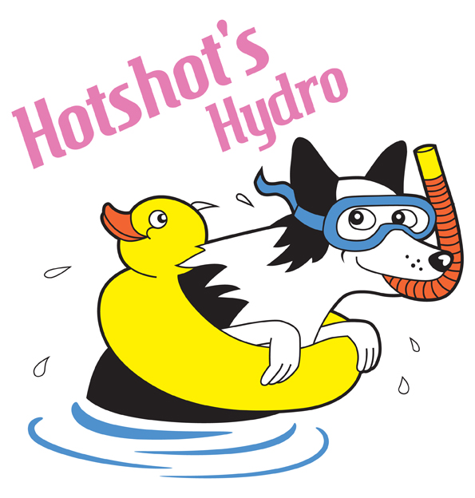

Unit 11, Farrier Rd

Lincoln, LN6 3RU

07456 871976

[info@hotshots-hydro.co.uk](mailto:info@hotshots-hydro.co.uk)

[www.hotshots-hydro.co.uk](http://www.hotshots-hydro.co.uk)

**Owner Details**

**Name…………………………………………………**

**Address……………………………………………..**

**………………………………………………………..**

**Tel……………………………………………………**

**Email…………………………………………………**

**Dogs Details**

**Name……………………………………………………**

**Breed……………………………………………………**

**Colour…………………………………………………..**

**DOB……………………………………………………..**

**Sex……………………………………………………….**

**Vaccinated……………………………………………….**

**Declaration**

I have received and fully accept the terms and conditions of treatment and understand that I, as the legal owner of the dog, accept full responsibility for divulging any and all facts that may be relevant during treatment, particularly in respect of the dogs health. I declare that all information shown on this form is correct.

**Signed**……………………………………………………….**Date**……………………………………………………….

**Veterinary Details**

**Practise Name…………………………………………………………………………………………………………….**

**Address………………………………………………………………………………………………………………………**

**…………………………………………………………………………………………………………………………………**

**Phone…………………………………………………………………………………………………………………………**

**Referring Veterinary Surgeon………………………………………………………………………………………….**

**Condition Summary………………………………………………………………………………………………………..**

**…………………………………………………………………………………………………………………………………**

**…………………………………………………………………………………………………………………………………**

**Medication (if applicable)…………………………………………………………………………………………………**

**Comments…………………………………………………………………………………………………………………..**

**…………………………………………………………………………………………………………………………………**

**Declaration**

I have examined the above dog and in my opinion it is in a suitable state for hydrotherapy treatment.

**Signed……………………………………………………………….Date………………………………………………….**